嚶鳴合唱團簡介
嚶鳴合唱團成立於一九九七年，次年四月註冊為一非牟利的音樂團體，以推動歌唱藝術、培養音樂興趣和促進澳門音樂文化為宗旨。成立後，除每年均舉辦周年音樂會外，亦多次赴香和國內參與演出及推廣澳門本土合唱作品；二零零一年邀請兩岸四地四隊合唱團到澳門舉行「四方樂韻匯濠江」三場合唱匯演；零二年七月，參加在北京舉行的第六屆中國國際合唱節，獲得“成年組銅獎”、“中國歌曲演唱獎”及“優秀伴奏獎”。
此外，多次應澳門政府邀請在重要項目中演出，計有：九九年澳門移交大典文藝晚會、第十二屆澳門藝術節與鋼琴家劉詩昆合作演出、二零零三年一月八日接待政協主席李瑞環的文藝晚會、二零零五年十月第十九屆澳門國際音樂節紀念冼星海一百週年誕辰音樂會《黃河大合唱》、二零零九年十二月十九日「慶祝澳門回歸祖國十周年文藝晚會」，以及二零零八年與二零零九均應文化局邀請與澳門樂團合作演出「聖音樂會」；二零一零年四月的復活節音樂會，其間，在呂嘉指揮下，與台北愛樂合唱團和澳門樂團合作演出孟德爾頌的第二交響曲《讚頌歌》；同年再度應邀與這兩個團體在十二月二十三日合作演出韓德爾的神劇《默西亞》中的合唱曲多首。
嚶鳴也曾應澳門和香的天主教教區的團體邀請，在莊嚴的禮儀中獻唱；此外，也曾與澳門其他音樂團體合作演出。
近年嚶鳴合唱團積極推廣本地作曲家的音樂作品，曾分別於零五年及零六年舉辦區師達神父合唱作品音樂會及林樂培聖樂合唱作品音樂會，並於零七年舉辦澳門本土合唱作品演唱會，二零零八年進而與澳門高等校際學院下設聖若瑟基督宗教研究中心合作錄製本土合唱作品專輯，並於該年十一月二十二日在聖若瑟修院聖堂舉行「二十世紀初至今的澳門本土合唱作品專輯」發行演唱會，有逾二百名的愛樂者作了見證。
二零一一年八月八日至十九日，應奧地利 Burgenland 州 Hornstein鎮政府邀請前赴司馬榮神父的家鄉Hornstein鎮，展開為期約十天的“嚶鳴合唱團奧地利音樂之旅”，八月十二日在St. Anna Parish Church舉行“司馬榮神父在澳門的創作演唱會”及八月十三在Eisenstadt市的Haydn Church舉行“澳門本土合唱作品演唱會”。“奧地利音樂之旅”將嚶鳴合唱團持續多年的“本土工作”推向一個新的領域----司馬榮神父的作品回流故鄉。而“司馬榮神父在澳創作演唱會”於七月二十四日在澳門舉行預演。
二零一二年十一月二十三日，發行了一部被搶救並確證為司馬榮神父所作的《降B大調彌撒曲》。
嚶鳴合唱團演唱曲目多元化，包括宗教歌曲、無伴奏合唱曲、中國藝術歌曲、各地民歌、百老匯音樂劇歌曲及澳門本土歌曲等。
二零零四年，設立專務無伴奏多聲部合唱曲小組。

Perosi Choir
Perosi Choir, with the objective of promoting the art of choral singing, cultivating the interest in music and boosting Macao’s musical culture, was founded in 1997, and was registered as a non-profit music body in April 1998. The Choir has been holding annual concerts ever since its establishment, and it has traveled to Hong Kong and to the Chinese mainland on many occasions for performances and promotion of Macao’s local choral compositions. In the concert “Melodies without Frontier” in 2001, the Choir invited top-notch choral groups from regions across the Straits to Macao to present three performances. In July 2002, the Choir joined the 6th China International Chorus Festival in Beijing and won the Third Prize, “Prize for Excellent Chorus of Chinese Work” and “Prize for Excellent Accompaniment”.
The Choir has been a frequent guest-performer at the invitation of the Macao SAR Government in many major functions, including the Macao Handover Ceremony in 1999; joint performance with the eminent pianist, Liu Shikun, during the 12th Macao Arts Festival; Celebration Show in honor of the visit of Li Ruihuan, the Chairman of the Chinese People’s Political Consultative Conference (CPPCC) on 8 January 2003; the “Yellow River Cantata” during the Commemorative Concert for the Centenary of the Birth of Xian Xinghai as part of the 19th Macao International Music Festival in October 2005; the “10th Macao Reunification Anniversary Celebration Show” on 19 December 2009; joint performance with the Macao Orchestra for the 2008 and 2009 “Christmas Concert” at the invitation of the Cultural Affairs Bureau; Easter Concert, April 2010, wherein the Choir collaborated with the Taipei Philharmonic Chamber Choir and the Macao Orchestra in singing Mendelssohn’s Symphony No. 2 “Lobgesang”, directed by Lü Jia. The Choir’s collaboration with the Taipei Philharmonic Chamber Choir and the Macao Orchestra continued in Handel’s Messiah in December 2010.
Perosi Choir receives and accepts various invitations from Catholic communities in the Dioceses of Macao and Hong Kong to participate in liturgical services. It has been in long-term partnership with other musical groups in Macao as well.
The Choir has an active role in promoting the works of local composers in recent years. These efforts include concerts such as “Choral Works of Fr. Áureo Castro”, “Choral Works of Doming Lam in celebrating his 80th Birthday” and “Macao Pieces”, which were held in 2005, 2006 and 2007. And in 2008 the Choir collaborated with Saint Joseph Center for Christian Studies of the University of Saint Joseph (formerly known as Macao Inter-University Institute) in the recording of an album of Macao’s local choral works. The Release Concert of "Macao Choral Works from the Beginning of the 20th Century to the Present" took place on 22 November, 2008 in the Chapel of Saint Joseph Seminary, witnessed by about 200 music lovers.
At the invitation of the Mayor Herbert Worshitz of Hornstein, Austria, Perosi Choir visited Hornstein, the birthplace of Father Wilhelm Schmid (1910-2000) in August, 2011. During the 10-day Musical Tour in Austria, the choir held at St. Anna Parish Church “Choral Works of Father Wilhelm Schmid in Macao”, at Haydn Church, “Macao Choral Pieces Concert”. The Musical Tour, a homeward journey of Father Schmid’s works, was a continuation and remarkable expansion of what Perosi Choir has been doing over the years. A preview concert of “Choral Works of Father Wilhelm Schmid in Macao” was held in Macau in July, 2011.
On 23 November, 2012, the Choir published a Mass in B^{b} major, a work rescued and later confirmed to have been composed by Father Wilhelm Schmid.
Perosi Choir has performed choral music of different sorts, ranging from religious hymns, a cappella pieces and folk songs of different countries, to Chinese artistic songs and Broadway musical themes, as well as Macao’s local compositions, some of which composed by the group itself.
In 2004, a small group focusing on singing a cappella works was established.

伍星洪 João Ng（指揮 / Conductor）
出生於澳門，自幼醉心於古典音樂，曾參與澳門多個堂區歌詠團及澳門複音合唱團。一九六九年與友人共創復民合唱團，從創團起至一九八二年一直擔任指揮，且每年領導該團作公開演出。伍氏曾隨美國音樂家Charles Duncan和澳門聖庇護十世音樂學院前院長區師達神父習和聲及作曲。一九九七年與林平良等人創立嚶鳴合唱團，並一直任指揮之職。二零零零年憑《歡唱大自然》一曲在香港童聲合唱協會與香港學校音樂及朗誦協會合辦的“童聲合唱歌曲創作大賽”C組（適合初中學生演唱）中獲得冠軍。伍氏一向關注澳門本土合唱作品的發掘、創作和推廣，於二零零五年起開始有計劃和有系統地帶領嚶鳴合唱團舉辦澳門本土合唱作品演唱會及進行專輯的錄製工作，該專輯的發行和啟聲儀式亦在主禮嘉賓和約二百位聽眾的見證下，於二零零八年十一月二十二日所舉行的“二十世紀初至今的澳門本土合唱作品專輯發行演唱會”中完成。亦因此，伍氏於二零零九年獲澳門特別行政區政府頒授功績獎狀，以表揚其對澳門文化的貢獻。二零一零年，確證一部在蓮溪廟舊物攤發現的《降B大調彌撒曲》為司馬榮神父所作。伍氏其他的合唱作品有《亞利路亞》、《一星弱火》、《秋夕》、《天主經》、《聖母頌》及《歡欣聖誕》等。
Born in Macao, João Ng’s love for classical music started at an early age. He has participated in a few church choirs and the Grupo Coral Polifónico. In 1969, he established the Folkman Choir with his friends and had been the conductor leading concerts annually till 1982; Ng studied harmony and composing under the guidance of American musician Charles Duncan and the former principal of St. Pio X Academy of Music, Fr. Áureo da Costa Nunes e Castro. In 1997, Ng, together with Young Lam and other music lovers, established the Perosi Choir, and since then, Ng has been the conductor of | 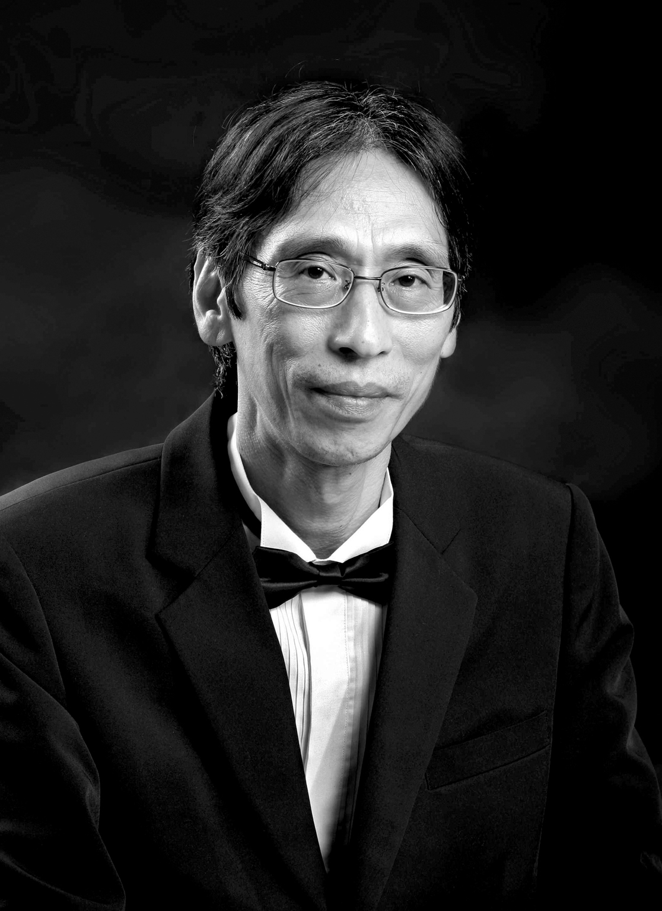
the Choir. In 2000, his song “Sing the Nature” won the 1st prize in the contest for composing choral songs for children（junior high students）held by Hong Kong Treble Choirs’ Association and Hong Kong Schools Music and Speech Association. He is an earnest advocate for discovering, composing and promoting local choral works of Macao. With careful planning, he has been leading the Perosi Choir in performing at a series of concerts featuring Macao’s local choral pieces since 2005. And during the same period of time he spearheaded the project of making a special album of these choral works. And the ceremony marking the birth of this album took place on 22 November, 2008, at the "Macao Choral Works from the Beginning of the 20th Century to the Present" Album Release Concert, under the witness of officiating guests and an audience of about 200. And in honour of his effort in contributing to Macao’s cultural advancement, the Macao SAR Government awarded Ng the Certificate of Merit in 2009. In 2010, Ng proved that a “Mass in B^{b} major”, discovered in a second-hand stall in Templo de Lin Kai, was written by the late Father Wilhelm Schmid. Ng’s other choral pieces include “Alleluia”, “A Faint Spark”, “7th Night of 7th Moon”, “The Lord’s Prayer”, “Ave Maria”, “Happy Christmas”, etc.

João Ng (maestro do Coro Perosi)
João Ng nasceu em Macau e desde cedo manifestou o seu amor pela música clássica, tendo participado em alguns coros de igreja e também no Grupo Coral Ponifónico. Em 1969 criou, com um grupo de amigos, o Coro Folkmen, do qual foi maestro até 1982, realizando concertos anuais. Ng fez estudos de Harmonia e Composição sob a orientação do músico americano Charles Duncan e do Pe. Áureo da Costa Nunes e Castro, antigo Director da Academia S. Pio X. Em 1997, juntamente com Young Lam e outros melómanos, Ng criou o Coro Perosi, do qual tem sido o director. Em 2000, a sua peça “Cantar a Natureza” ganhou o 1o Prémio no Concurso Estudantil de Composição de Canto Coral, realizado pela Associação de Coros Treble de Hong Kong e pela Associação de Retórica e Escolas de Música de Hong Kong. Ng tem sido muito activo na descoberta, composição e promoção de obras de canto coral em Macau, além de cuidar do planeamento e de reger, desde 2005, as actuações do Coro Perosi numa série de espectáculos com peças de canto coral locais. Foi também o impulsionador do projecto discográfico de um álbum com estas obras, intitulado “Obras Corais de Macau desde inícios do Século XX até ao Presente”, cujo concerto homónimo de lançamento teve lugar a 22 de Novembro de 2008, com a presença de distintos convidados e um público de cerca de 200 pessoas. Em homenagem a estes seus esforços de promoção da cultura musical em Macau, o Governo da RAEM atribui-lhe o Título Honorífico de Valor em 2009. Em 2010, Ng provou que a peça “Missa em Si bemol maior” descoberta numa tendinha de artigos usados do Templo Lin Kai e de autoria do falecido Pe. Guilherme Schmid. Do próprio Ng, as pecas corais mais conhecidas são “Alelluia”, “Uma Faísca Fraca”, “7a Noite da 7a Lua”, “Prece do Senhor”, “Ave Maria” e “Feliz Natal”.

王嘉祺 Katrine K. Wong (助理指揮 / Assistant Conductor)

王嘉祺出生於香港。1999年考獲英國聖三一學院FTCL(鋼琴)和LTCL(聲樂)。王氏分別跟隨黃懿倫與畢詠琴學習鋼琴和聲樂，並獲得很多音樂獎學金，包括鋼琴金牌獎，嘉遜修士聲樂獎學金，費明儀女士聲樂獎學金等。多年以來，王氏以獨唱者和合唱員身份跟世界各地多個合唱團表演，例如英國利玆大學禮儀合唱團，哈佛大學仲夏合唱團，香港雅詠團，拔萃女書院舊生合唱團。2005年獲邀以海外傑青身份在人民大會堂擔任領唱。
王氏2008年來到澳門，現任澳門大學英文系助理教授。2004年獲得尤德爵士紀念研究生獎學金負笈利玆大學，2008年獲頒英國文學博士銜，亦持有英國高等教育學院專業銜AHEA。個人著作包括Music and Gender in English Renaissance Drama (Routledge: New York, 2012)，並與澳門大學歷史教授魏楚雄合編Macao: Cultural Interactions and Literary Representations (Routledge: Oxford, forthcoming)。王氏亦被邀為戴定澄著作《20世紀澳門天主教音樂－－獨特歷史背景下的作曲者與作品》擔任英文版責任編輯，該書將由澳門文化局出版。

Katrine Wong was born in Hong Kong. She obtained both her FTCL (Piano) and LTCL (Voice) in 1999. During her school years in Hong Kong, she received piano and vocal training from Ms Eleanor Wong and Ms Rosaline Pi respectively. Wong won many piano and voice scholarships such as Gold Medal Award, Brother Cassian Scholarship for Singers, Barbara Fei Vocal Scholarships. Over the years, Wong has performed internationally as soloist and choir member with various choirs, including Leeds University Liturgical Choir, Harvard Summer Chorus, Hong Kong Chamber Choir, and Diocesan Graduate Singers (DOGA). She was invited to sing as the leader in Great Hall
of the People during China Synergy Programme in 2005.
Wong came to Macao in 2008 and is currently Assistant Professor at University of Macau. She was awarded a Sir Edward Youde Memorial Fellowship in 2004 and received her PhD from University of Leeds in 2008. She holds the professional title of AHEA, a teaching recognition awarded by the Higher Education Academy in the U.K. She is the author of Music and Gender in English Renaissance Drama (Routledge: New York, 2012) and co-editor of Macao: Cultural Interactions and Literary Representations (Routledge: Oxford, forthcoming). She is also editor of the English version of Dai Dingcheng’s Catholic Music of Macao in the Twentieth Century: Composers and their Works in a Unique Historical Context (Macao: Instituto Cultural, forthcoming).

